**lR and val_acc table**

|  |  |
| --- | --- |
| **LR** | **Validation_accuracy** |
| 0.1 | 100% |
| 0.01 | 96.875% |
| 0.001 | 95.8334% |
| 0.0001 | 100% |
| 0.00001 | 62.5% |

**Best Validation_accuracy at lr = 0.1 & 0.0001**

**Graph of train_loss vs epoch for lr = 0.1**

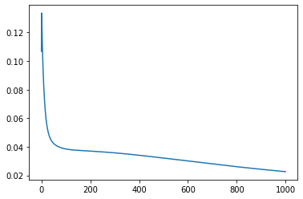

**Graph of train_loss vs epoch for lr = 0.0001**

